* **[How to save your site as a template](https://sharepoint.rackspace.com/Learning/Articles/Pages/SharePoint-2013--how-to-save-your-site-as-a-template.aspx)**

Creating a site template is a simple and efficient way to maintain consistency throughout your SharePoint environment.  Whether you decide to save the template with content or without, this feature will certainly prove helpful. There are a few things to keep in mind when creating a site template though, such as Publishing features and site template limitations. If SharePoint Publishing features are enabled, you will not be able to utilize the "Save Site as Template" feature as this is not supported.  For more information about the SharePoint Publishing feature click [**here**](http://support.microsoft.com/kb/2492356). For additional information about what items can be saved in a site template click [**here**](http://msdn.microsoft.com/en-us/library/office/jj938033%28v=office.15%29.aspx).

1. From your SharePoint site, on the Home Page, click the **Site Settings gear** icon.

https://sharepoint.rackspace.com/Learning/Articles/PublishingImages/How%20to%20save%20your%20site%20as%20a%20template/sitetemplate1.png

2. From the drop-down click **Site settings**.

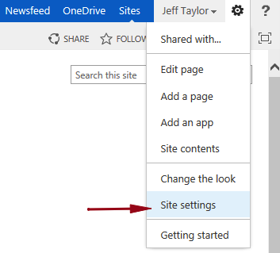

3. On the Site Settings page under Site Actions, click **Save site as template**.

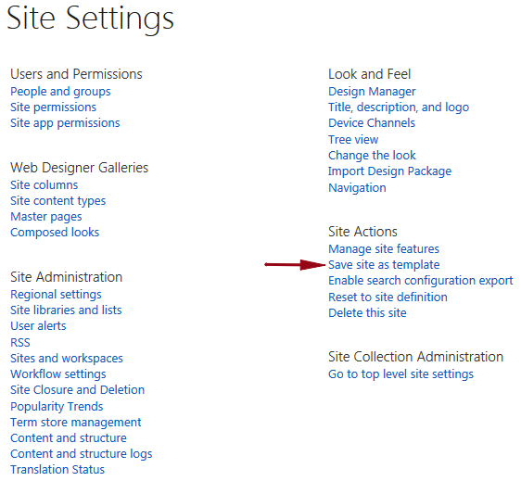

4. In the File Name section give it a name, for this example I will call it **IT Subsite**.

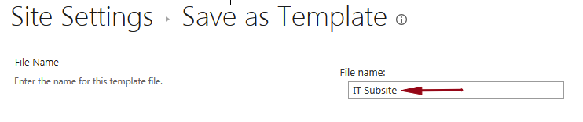

5. In the Name and Description section under Template name: give it a name, for this example I will use **IT Subsite Template**.



6. Under description: type **This is a template for the IT subsite, with content**.

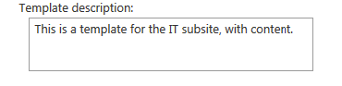

7. In the Include Content section check the box next to **Include Content**.

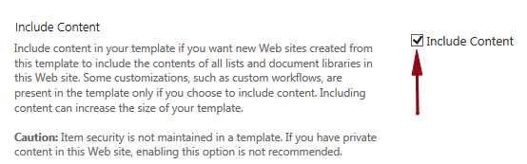

8. Review and click **OK**.

<https://www.youtube.com/watch?v=yKlgAAINPMc>

9. On the Operation Completed Successfully screen click **OK**.

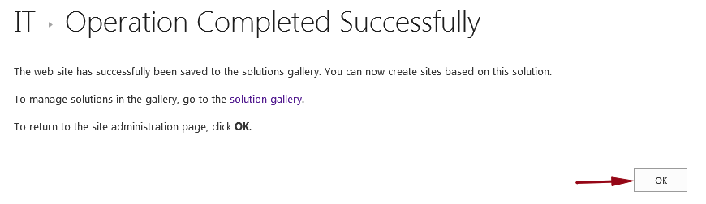

Pretty painless! You might be wondering, how do I create a new site with this template? Great question! Check out [**SharePoint-2013: How to create a site with a template**](https://sharepoint.rackspace.com/Learning/Articles/Pages/SharePoint-2013--how-to-create-a-site-with-a-template.aspx) for step-by-step instructions.